- \Operation\Product sensing\Product sensing
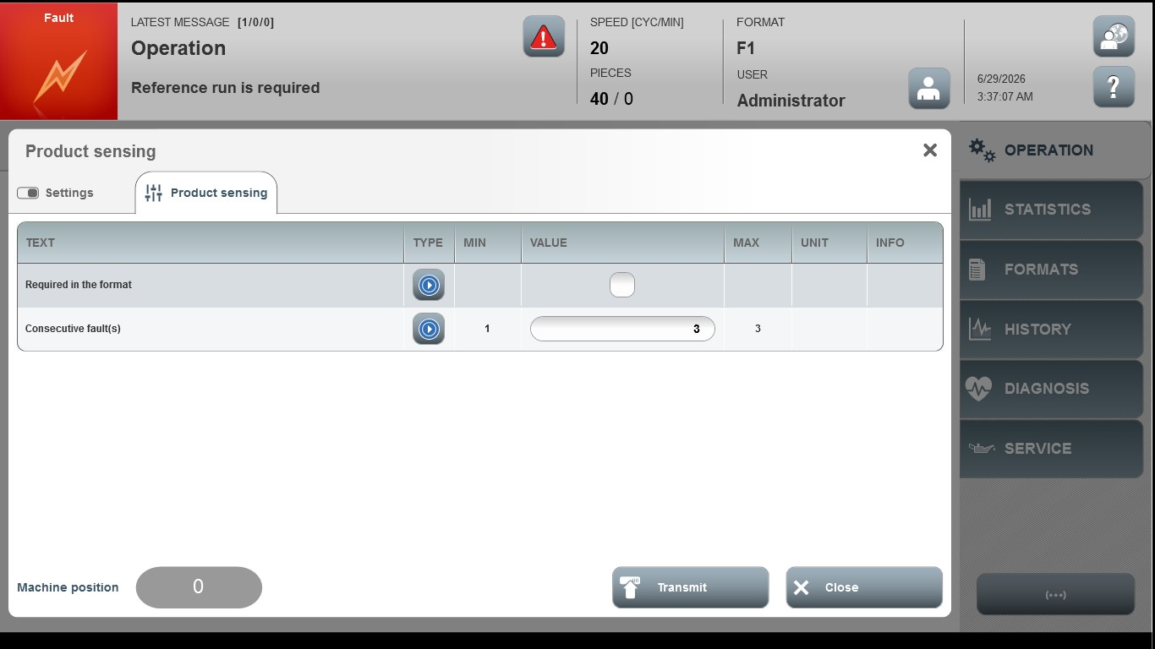
Acceptance criterion | Limits | Pass / Fail: Dev-No. | Date | Initials
Screen matches screenshot | N / A
Consecutive fault(s) | 1…3

